St. Paul’s Weekly Update – June 2, 2022

Minister’s Ponderings
Our weekly update has several notes thanking volunteers for various acts of kindness and assistance. This does not even include the people who have faithfully served on committees, those who have cleaned throughout the pandemic or used their technology skills to assist in worship or in Zoom meetings. Our staff have gone the extra mile and more so during the pandemic. If it were not for the volunteers who have come forward, St. Paul’s might have found us, like many other churches, wondering about our future and pondering closing our doors. We came together as a congregation. For those of you who stepped up to the plate, we cannot thank you enough. Yet to those who do step up, it is at times discouraging that it is often the same people again and again. The truth is that the church is a not a building but is the whole people of God who come together for the work and ministry of Jesus Christ. I encourage you if you can, to perhaps ponder and pray about your call to ministry within St. Paul’s and to consider volunteering when you see the requests for volunteers. We need you. We are in the midst of regrouping and rebuilding and envisioning our future.

Worship
This Sunday is Pentecost Sunday. It is a service of joy and celebration of the Holy Spirit in our lives and in our world. It is a service that goes back to the start of the early church and how God led them beyond fear and grief to courage and compassion. It is also communion. For those who are watching on-line, I invite you to have bread or crackers on hand and a beverage to join us in the Lord’s Supper.

Worship with us in person at 10:00 a.m. or on-line, visit our website at www.stpaulsmidland.org and use the direct YouTube link at the top of the page, or simply go to YouTube and subscribe to our channel. Just type in “St. Paul’s Midland” and you will find us. If you are on Facebook, you can get St. Paul’s updates that way as well. Check us out on both our new website and Facebook. We start live-streaming at 10:00 a.m. every Sunday.

The Official Board will be meeting via ZOOM next Tuesday, June 7th at 7:00 p.m. All Board members are asked to attend.

Congregational Life
THANK YOU to Betty Ann Bell, Sue Dorion, Marlis Dupuis, Donna MacFarlane, Lenore Price, Gail Wilcox and Linda Wilcox for getting the church kitchen cleaned. It was a seven-week process - one morning a week, but it is now clean from top to bottom and from inside out. We also cleaned the storage room beside the kitchen. This room will always and forever be known as “Gary's room”.
THANK YOU. We would like to express our thanks to those who cared for the coleus and dahlia tubers over the winter. They are now in the ground and they certainly brighten the gardens. We are also grateful to the gardeners who helped dig, weed and plant dahlia tubers and the coleus - Ivan and Lenore Price, Gale Wilcox, Linda Wilcox and Peggy Wallace. We very much appreciate the work of the Discovery Kids who planted seeds in the garden closest to the ramp and helped to plant some coleus. Every little contribution helps us and we benefit with the beautiful gardens - please take time to enjoy them. Thanks to Carol MacDonald who organized all of this and spent hours on our behalf.

THANK YOU to those who have volunteered to help with the return of our Coffee Social Hour. We have three team leaders (need two more), a few volunteers and a lovely lady who isn't able to prepare or serve but will bake cookies. For more information or to volunteer, please contact Sheila at rmsmt@rogers.com or 705-526-2186.

THANK YOU to everyone who supported our Faith and Fellowship fundraising dinner this week. We raised $1,145.08, which will go towards church expenses. A special thanks to Zena, Sheila and their team of volunteers (Betty Ann Bell, Lenore Price, Sue Dorion, Gail Wilcox and Gerry Payne) who made all of this happen.

THANK YOU to those who have faithfully assisted in cleaning the church building. A special thanks to Bruce Wilcox who has done so much in the absence of a custodian. We also want to thank Sue Dorion, Colleen Gareau, Larry Brockelbank, Lenore and Ivan Price, Zena Pendlebury and Louise Leck.

Congratulations to Joan Goodfellow who recently celebrated her 99th birthday! She was at church this past Sunday and it was good to see her. Also, we learned from the Midland newspaper “The Mirror” that Paul and Theresa Henderson are celebrating their 50th Wedding Anniversary on June 2nd. Congratulation to them and those whose 50th, 60th, 70th Anniversaries we did not know about.

St. Paul’s Zoom Coffee Hour
The next ZOOM Coffee Hour is on Sunday June 12th,2022, at 1:00 p.m. We invite you all to join. Thank you to Liz Rogers and her Zoom team for making this happen. You can use the same link as before: https://us02web.zoom.us/j/89969004401

Memorial Celebration:
The family of Max Wagg have asked us to invite you to a Celebration of Life for Max (1934-2021). Max was a teacher, bus driver, syruper, and ultimate handyman. You are invited to join with family and friends on June 13, 2022, anytime between 12:00 and 2:00 p.m. at J.H. Lynn Chapel at 290 1st St. Midland. At 2:15 p.m. there will be a dedication of a bench donated by the family here at St. Paul’s United Church on our front lawn. All are invited.

St. Paul’s UCW will meet on Tuesday, June 14th at 1:30 in the Parlour. All ladies are invited to join. Barb Carswell will be doing a presentation about her surgical mission trip to Guatemala. A short business meeting will follow.

Refugee Update:
The Refugee committee and St. Paul’s is very grateful to the Midland Rotary Club for a grant of $20,000 toward our refugee work. We are currently assisting three families. One family is a family of eight, another a family of six and a third a family of three. We continue to work with St. Mark’s Anglican/Lutheran Church in this important work.

THANK YOU to Tom Barber, Bruce Wilcox, Rick Gerritsen, Martin Giebel, Keith Stam, John McGrory and Zena Pendlebury for assisting in delivering furniture to two of our Refugee families. Thanks also to Barber and Haskill for the use of their delivery truck. We don’t need any more furniture at this time but when we know of a need, we will reach out to the congregation.

Discovery Kids
We are very happy to announce that Discovery Kids are back in person every Sunday. Families are asked to take their children directly upstairs, where Rebecca is looking forward to seeing you.

Camp Awesome for ages 5-12 years will be from August 8-12, 2022, at the church. Stay tuned for more details and instructions on how to register. All are welcome -- you do not need to attend St. Paul's to register. Camp Awesome has been a wonderful week of fun for the participants. For Camp Awesome, we are calling all beekeepers! Rebecca and the Discovery Kids are in search of a local beekeeper who might be willing to be a part of some of our 2022 summer programming. If you have bees or know someone who does, please reach out to Rebecca at rebeccaamadei@gmail.com. Thank you!

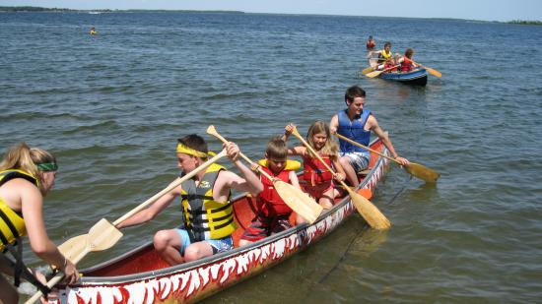
Camp Simpresca
Once again, Camp Simpresca is open to campers this summer. Financial assistance is available from St. Paul’s to help with registration fees to send children to the camp. For more information, call Louise at 705-526-1640 or email the church office at stpaulsunited@rogers.com. You can also check out the Camp Simpresca website at https://simpresca.camp/what-we-do/ to see what’s available.

This Week’s Minute for Mission
Irina in a refugee shelter
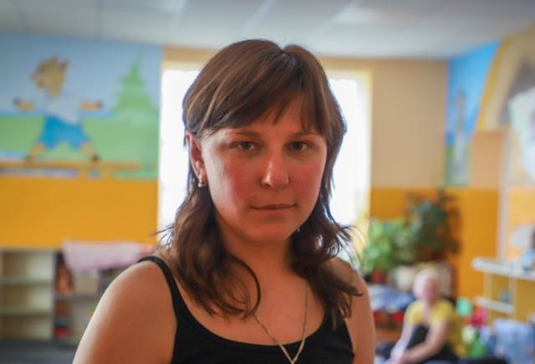
The latest stats released by the United Nations are mind-boggling: more than 12 million people are believed to have fled their homes in Ukraine since the invasion began. Over 5.7 million have left for neighbouring countries, and another 6.5 million people are thought to be displaced inside the war-torn country itself.

Irina, a trained nurse, is one of these millions of people whose family has been torn apart by war. Her husband, a history teacher, joined the territorial defence in the first days of the occupation. In the beginning, Irina and her five- and eight-year-old children moved in with her parents; because the home didn’t have a basement, they rearranged sofas and furniture to create safe shelter. When a bomb exploded in the neighbourhood, Irina had a tough decision to make. Her parents did not want to leave their beloved home, but as a mother she felt she needed to get her children to safety.

After a lot of agonizing soul-searching, Irina parted with her parents and started walking with her children toward the evacuation point. They were forced to take cover as shelling grew near. Eventually, the family was able to catch a train to western Lviv―a 20-hour journey―and then endured another exhausting 5-hour train ride to Batiovo, Transcarpathia.

In Batiovo, they were welcomed into one of 120 refugee centres and shelters. Through bilateral partnership with Hungarian Interchurch Aid held in relationship by ACT Alliance, your generous gifts are helping to provide these centres and shelters with food, water, hygiene products and household appliances.

There, thousands of people like Irina and her children have found shelter and warm meals and volunteers are doing what they can to offer support and help keep spirits up. For now, the family isn’t crossing the border; Irina’s husband, sister, and parents are in Ukraine and Irina doesn’t want to leave them farther behind. She recognizes this might not be an option in the future.

In an unimaginably difficult time, your gifts are not only helping to provide necessities, they are also showing the people of Ukraine you care. Thank you so very much for your compassion. Please continue to hold Irina and the people of Ukraine in your prayers.

Blessings everyone,
Rev. Karen Ptolemy-Stam, Minister, St. Paul’s United Church 705-433-1224
minspucmidland@gmail.com

Church Administrator – Louise Therrien, 705-526-1640 stpaulsunited@rogers.com

